PE Funding

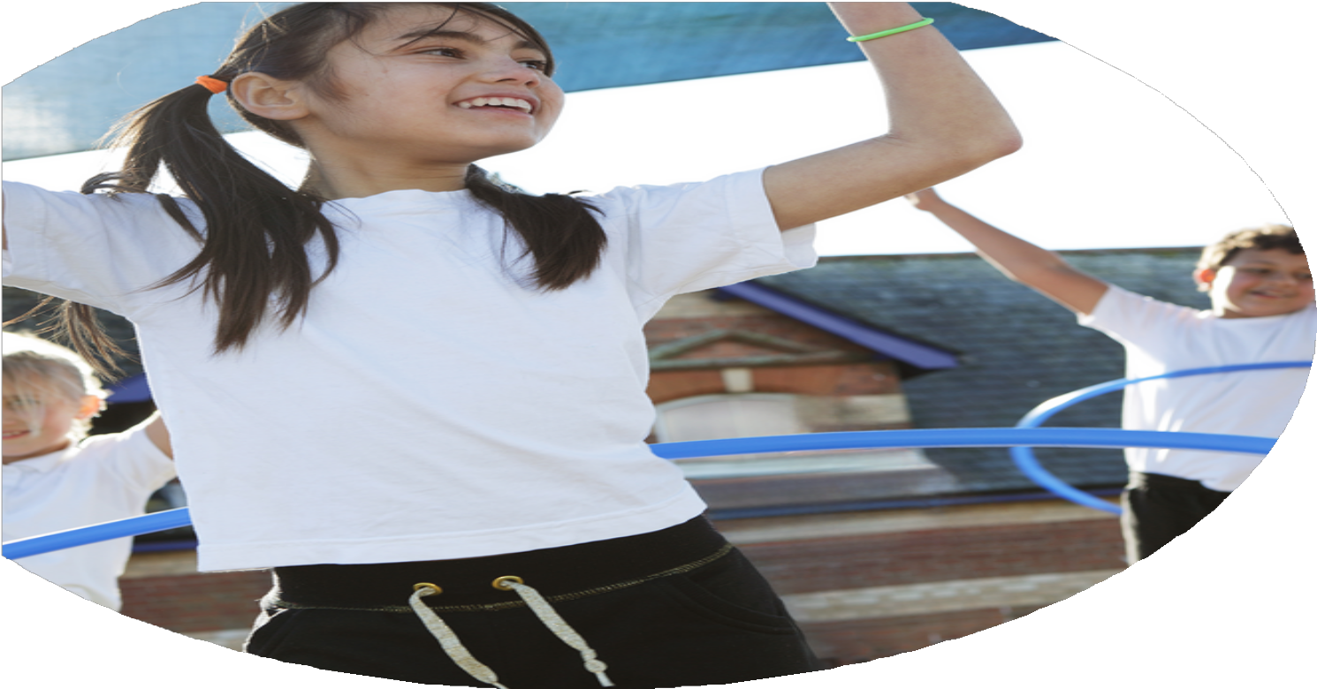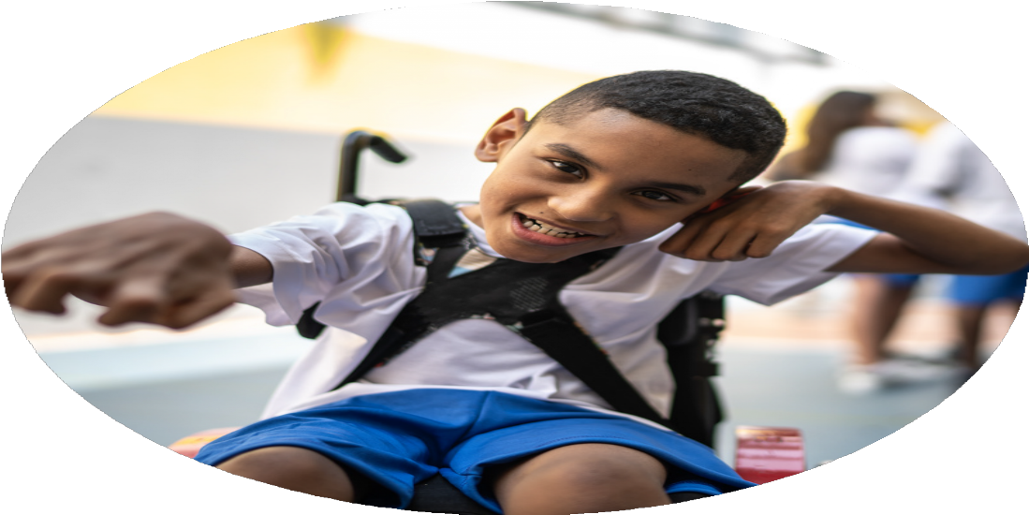

Evaluation Form

Barley Mow Primary School

2024-25



**Commissioned by**

**Created by**

Images courtesy of Youth Sport Trust

**PE Funding Evaluation Form**

 It is intended that this template should be used as preparation for the completion of the statutory digital reporting tool being introduced this academic year. You can upload data (including swimming) from this template onto this platform once it becomes accessible.

 Before you decide how you are going to use the funding for this academic year you should reflect and evaluate the impact of your use of the funding in 2023/24.

 All spending of the funding must conform with the terms outlined in the Conditions of Grant document.  The template is a working document that you can amend/update during the year.

 Based on your evaluation of last year’s funding you should decide what you intend to do this academic year, how you will do it, and what impact you expect it to have.

It is important that the funding is used effectively and based on your school’s needs.

 You must use the funding to make additional and sustainable improvements to the PE and sport in your school.  You must develop and add to the PESSPA activities that your school already offers.

*Summative digital reporting from June 2025 will continue to include swimming and water safety information therefore funding can be used to provide top-up lessons where necessary to ensure pupils meet national curriculum swimming requirements.*

We were not able to attend some events due to staffing or cost of transport to venues.

Staff feedback.

Costings and budget.

Feedback from Schools Games Mark and SSP

Feedback from staff and coaches

Staff available to attend events.

Ensuring children are competition ready. Sometime children lacked certain knowledge linked to a particular sport during the competition or festival

Transport costs. Due to locations of the events we need a bus to transport children. We are not near a metro or walking distance to venues.

Promotion of Physical Literacy to stake holders.

Engagement of less active children

The number of competitions able to enter due to transport costs, staffing and numbers of pupils allowed to participate in the organised event.

Sometimes the weather hindered coaching and impacted on the overall quality of lessons due to space.

Raising the profile of PE across school

Development of staff knowledge in a range of sports by offering training and coaching opportunities.

Affiliation to Gateshead School Sports Partnership Premium Membership

Achieving silver in Schools Games Mark Award

NUFC Foundation Coaching (Lessons and afterschool)

Feedback from children, stakeholders and staff recognise the importance of PE and see it as an essential part of our school improvement.

Staff feedback was positive used ideas/teaching from coaching to deliver high quality PE lessons.

This generated access to a range cross cluster days, sport festivals, staff development, (eg gymnastics coach) workshops, conferences and ideas. KS2 children participated in a growing range of sporting events involving inter school competition. All this supported the development of teamwork skills, perseverance, resilience and the importance of exercise.

Schools Games Mark action plan helped generate clear targets and evidence to support award.

All KS1 and KS2children participated in a range of sporting activities and received high quality coaching and teaching both within the school day and after school clubs.

Total Amount allocated: Budget: £17,240

What are your plans for 2024/25?

Intent

How are you going to action and achieve these plans?

Implementation

* PE Lead to liaise with SSP to ensure participation in a range of CPD, competitions and sports events. Where possible enter more teams to events across age groups.
* PE lead to liaise with NFC to deliver a range of sports across Year 1 -6 supporting staff and children. Timetables and planning to be agreed and discussed. Teachers to team teach in lessons.
* PE lead to discuss with staff specialist coaching they would like to support teaching eg gymnastics.
* Clubs to run across all year groups and engage different skills and interests. Clubs to be provided free or subsidized. Clubs to be run by NUF, Creative Dance and staff. Clubs will support sporting interests and physical activity but also to prepare children to be competent and ready for competition and sporting events.
* Purchase scheme and allow staff time to review and look at planning and resources.
* Ensure all children are given the opportunity across the school to participate in a competition or festival. Ensure transport is budgeted for. Source quotes early.
* Further training for staff to expand range of knowledge and ways children can be more active
* Audit resources for active play and update linked to interests to ensure children have suitable and effective equipment.
* Attend CPD from GSSP to support Gold Award. Prepare a clear action plan.
* Affiliation to Gateshead SSP Premium Membership and Schools Health and Wellbeing SLA to support access to sporting events in order to enter more children and teams into events and competition.
* Renew Newcastle United Foundation Bronze Package to support the delivery of high quality PE provision and staff subject knowledge.
* Book coaching across whole school in various fields and specialists to support high delivery PE provision and staff subject knowledge. Staff to be upskilled.
* Provide a full range of extra curriculum activities for children to allow them to access sporting activities and promote involvement.
* Renew PE scheme subscription to support subject knowledge, high quality planning resources and ideas.
* Provide free transport costs to competitive events to Gateshead Stadium and other venues for festivals and competition.
* Deploy lunchtime staff/ TAs employed to support and encourage children to take part in active play.
* Purchase resources to support playtime and sporting competition.
* Maintaining silver in Schools Games Mark Award with the aim of Gold Award.

What impact/intended impact/sustainability are you

expecting?

How will you know? What **evidence** do you have or

expect to have?

* Competition results/certificates/medals
* Photographs or videos
* Pupil Voice and pupil focus group
* Website posts
* Engagement in club and attendance registers.
* Class teachers/lunch staff monitor activity
* Sport leader feedback
* School Games Mark
* Opportunities increased to participate in competitions and festivals.
* Staff able to access quality CPD and training and feel confident to deliver high quality PE.
* Staff confidence increased to teach a wide range of sport.
* Staff knowledge increased with how to plan structure and deliver a lesson including adaptive teaching to support inclusion.
* More pupils meeting daily physical target.
* More pupils experience a range of extra- curricular activity.
* Opportunities for intra sport during extra- curricular activities.
* Providing support to staff with planning and effective delivery of PE.
* Children to take part in inter competitions where they can apply taught skills and be competition ready.
* Learn life skills faced with competition.
* More pupils encouraged and want to take part in active play.
* Fundamental skills develop.
* Stamina and fitness improve.

What **impact/sustainability** have you seen?

What **evidence** do you have?

100% of pupils attended either a competitive or non- competitive event outside school organised by SSP or Lord Lawson. The children were extremely enthusiastic about the events and gained new skills and experiences. PE documentation and website posts showcase this.

Children achieved certificates and medals from events.

The PE LTP showcases a range of sport inline with the National Curriculum.

Club timetables and registers evidence uptake and attendance. We listen to pupil voice to provide clubs children are interested in and enjoy. Sport clubs have regular attendance. Children often share with staff that they have went on to join sport clubs outside of school or bought certain equipment such a cricket set from in school experiences. They bring in medals or certificates to share and celebrate.

Sports Mark Gold Award 2025.

Increased active time during playtimes and afternoons has supported more children to meet daily physical target.

Feedback and pupil voice.

More children experienced competitions and sports festivals. This needs to continue next year and continue to enter more teams to SSP events so pupils experience competition and learn life skills faced in such events.

Children enjoy a range of sport.

PE has a high profile across school. The School Games Mark action plan has had high priority and an area of school improvement for physical activity and engagement linked to active play, competition and extra- curricular engagement.

Staff continue to develop subject knowledge and be upskilled in the delivery of PE.