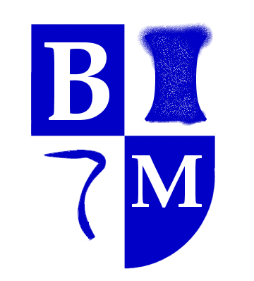

Art and Design
Artist study : Henri Rousseau
Art inspired by Rousseau

Design Technology

Making Pizzas

Geography
Naming seas and oceans in the UK
What is it like to live by the coast?
.

Computing
ICT around us
Questioning and Pictograms

PE
Sending and Receiving: Tennis
Athletics

Science
Living things and their habitats.

Music
Space music and soundscapes
Musical Me

Literacy
Honey Bees – nonfiction report
The Owl who was Afraid of the Dark – narrative.
Poetry Study – Classic Poet.

Numeracy
Measures including length, mass, temperature and capacity
Fractions -halves, thirds, quarters.
Statistics
Position and direction

Consolidation of 4 arithmetic operations.
Mastering Number NCETM
Times Tables Recall.

RE
Christian Rites of Passage
What do Muslims celebrate?

PHSE and Citizenship
Citizenship
Economic Wellbeing
Transition

Year 2
Summer Term

What your child will be learning this term.
If you would like more detail please contact
Mrs Chapman

History
Learn about significant people from the past and their legacy.
Florence Nightingale and Mary Seacole.

