Here are the details of our curriculum for this term
If you would like more detail please talk to the class teacher.


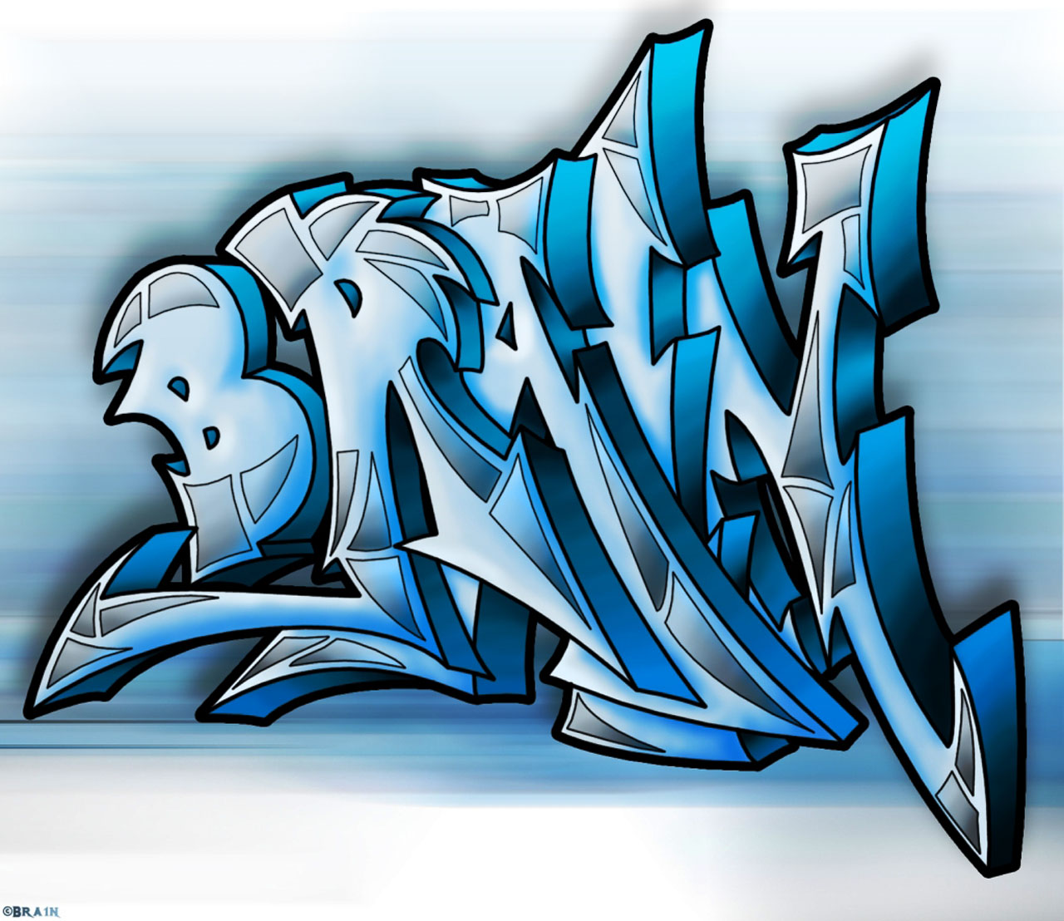
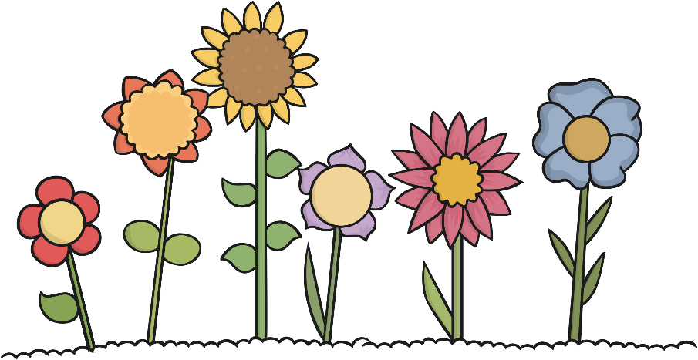

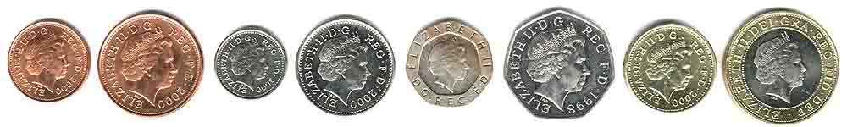
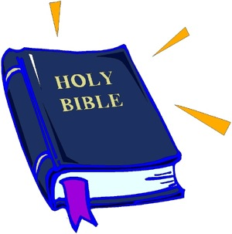

History
Use historical words to describe the passing of time.
To know how people in the past enjoyed seaside holidays.
Local heroine - Grace Darling.
Visit to St Mary’s Lighthouse.

Geography
What is it like to live in Shanghai?

Computing
Coding and computational thinking
Privacy and security
Technology outside school
Copyright and ownership

PE
Net and wall
Sending and receiving
Athletics
Team building games.

Science – Plants & Animals
Identify and describe common plants.
Grow seeds into plants, monitoring and recording their growth.
Label the main parts of a plant.
Identify deciduous and evergreen trees.
Identify and name a variety of common animals including fish, amphibians, reptiles, birds and mammals.
Identify and name animals that are carnivores, herbivores and omnivores.

Music
Pitch and Tempo

English
Using capital letters for days of the week, months of the year, people and places.
Making plurals by adding –s or -es.
Writing in complete sentences with punctuation including . ? !
Using conjunctions to join two sentences.
Writing narratives to develop detail and vocabulary.
Exploring acrostic poems.
Texts include: The Smartest Giant in Town and The Light House Keepers lunch.

Maths
Multiplication and Division
Counting in 2s, 5s and 10s
Place Value (numbers to 100)
Money – recognise all coins and notes, solve Money problems
Fractions
Geometry – position and direction
Reading the time to the hour and half hour

PSHE
Citizenship
Economic wellbeing

Year 1
Summer 2025

Art & DT
To make African Art.
Explore work by Thandiwe Murui.
To create moving minibeasts.

RE
What did Jesus teach us?
What do Hindus celebrate?

